Data demands and availability in the project communities
Second peer learning session
Date: 16 December 2022
Time: 13:00-14:30 CEST
As part of the “Engaging communities in a just transition” project, funded by the Ford Foundation, the EITI’s International Secretariat convened a second peer learning session with consultants from Colombia, Ghana and Indonesia. The aim of the session was to discuss what disclosures and processes are most relevant for helping communities understand how the energy transition is impacting their livelihoods. This was achieved by identifying the community’s interest, awareness and use of subnational data disclosures.

Background
- The “Engaging communities in a just transition” project explores the obstacles communities face in accessing and using data on extractive industries and energy projects. The energy transition potentially has profound implications for subnational revenue flows, jobs, community investments and environmental and social impacts. The project engages stakeholders to identify data gaps and to show how disclosures and dialogue can help to strengthen the voice of communities. The EITI is implementing the project in Colombia, Ghana and Indonesia over a two-year period.
- In December 2022, the International Secretariat convened a peer learning session to share lessons from component 1 of the project, which the consultants completed in September. The purpose of the peer learning session was to identify and compare community interest, awareness and use of information disclosures related to the energy transition’s impacts on their livelihoods.
- For this exercise, consultants used the scoring card below to map existing subnational disclosures against community’s interest, awareness and use of information.

Scoring guide
Color | Existing EITI disclosures | Other disclosures | Community interest | Community awareness | Community use
Green | Existing EITI disclosures are comprehensive, accessible and timely in this area | Disclosures from other data sources are comprehensive, accessible and timely in this area | Community members have expressed strong interest in disclosures related to this area | Community members have a good awareness of where and how to access existing disclosures in this area | Community members regularly access and use disclosures in this area
Amber | The EITI provides some disclosures in this area but there are important gaps | Other sources provide some disclosures in this area but there are important gaps | Community members have expressed moderate interest in disclosures related to this area | Community members have some awareness of where and how to access existing disclosures in this area but there are important gaps | Community members occasionally access and use disclosures in this area
Red | There are very few or no existing EITI disclosures in this area | There are very few or no existing disclosures from other data sources in this area | Community members have expressed low interest in disclosures related to this area | Community members have low or no awareness of where and how to access existing disclosures in this area | Community members rarely or never access and use disclosures in this area

Key findings
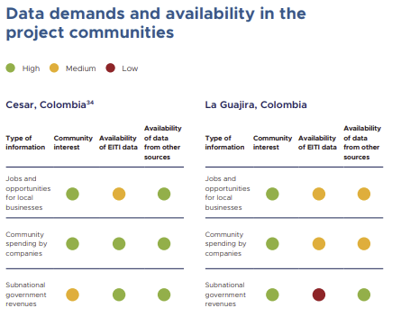
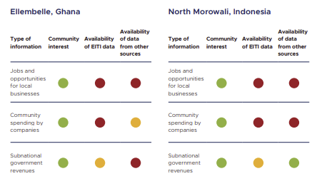

Community interest in disclosures highlighting the Environmental and Social impacts is high across all four communities. However, EITI disclosures and disclosures from other data sources are considered few, non-existing in Ghana. There are some disclosures with important gaps in La Guajira, Colombia, and Indonesia. In Cesar, environmental and social impact disclosure seem comprehensive and accessible.
Community interest in disclosures related to license and company information is high across all four communities. However, EITI provides some disclosures in this area but there are important gaps. Disclosures on license and company information from other data sources are considered more comprehensive and accessible than those provided by the EITI.
Community expressed moderate interest in disclosures related to policy and institutional framework. Even though, EITI disclosures and disclosures from other sources are considered comprehensive and accessible in all four communities.
Community interest in disclosures on production, volumes and values is high in Indonesia and Ghana and moderate in La guajira and Cesar, disclosures on this area from other data sources are comprehensive and accessible in Ghana, La guajira and Cesar, while in Indonesia has some disclosures but there are important gaps. EITI disclosures in Ghana are comprehensive and accessible, while in La guajira and Cesar and Indonesia are moderate.
Community interest in disclosures highlighting subnational budgets and revenue flows is high in Indonesia and Ghana; and moderate in La guajira and Cesar. However, EITI disclosures and disclosures from other data sources relate to subnational budgets and revenue flows are considered comprehensive and accessible in Indonesia, La guajira and Cesar. In Ghana EITI disclosures and disclosures from other data sources are few, non-existing.
Community interest in data highlighting the energy transition’s impacts is high – both in terms of EITI disclosures and disclosures from other sources. Across all four communities, stakeholders are particularly interested in information that relates to tangible impacts on their livelihoods such as jobs, business opportunities and obligations tied to companies’ corporate social responsibility (CSR) programmes.
However, knowledge about and use of existing disclosures is low to non-existent at the community level. The very low use of data in communities across the three countries relates to access difficulties which are tied to different barriers. In Indonesia, for example, communities noted that they did not know how to access data on subnational budgets and revenue flows. In Ghana, community awareness of the extractive industries was high, but knowledge of the EITI was low.
Other sources provide relevant data that is missing from EITI reporting. For example, in Indonesia information on the energy transition/renewable energy is not disclosed through EITI reports but some disclosures are available elsewhere. In such instances, the EITI may be able to point stakeholders towards existing data sources.
Communities have differing interests and needs. Context-specific policies need to be implemented to avoid misleading blanket approaches. This need for tailored approaches was exemplified by looking at two different communities in Columbia (La Guajira, Cesar). In La Guajira, for example, communities have awareness of some policy and institutional framework disclosures, whereas in Cesar they have none.
The concept of “energy transition” has little resonance in communities. In Indonesia, for example, communities understand that the government wants to increase nickel mining and nickel processing, but they do not draw the link between these developments and broader energy transition and climate change discussions. The energy transition is generally only of interest to communities in terms of its immediate impacts on their livelihoods.

Next steps:
- Consultants to incorporate findings and lessons from the subnational data disclosures table into the national engagement plans.
- EITI International Secretariat to refine the table used during the session and maintain it as a working document that can get updated as the project progresses. Areas for refinement include:
- Improving the integration of energy considerations in the assessment.
- Disaggregating data categories to get a more precise and targeted assessment, for example with regards to “broader economic contributions”.
- Encouraging more nuanced prioritisation around which information is truly vital for communities.

