This brief describes the links between the EITI and the Mining Local Procurement Reporting Mechanism (LPRM), including how EITI members can promote increased local procurement and transparency through using the system. Where relevant, aspects were drawn directly the Mining LPRM which can be downloaded at www.miningsharedvalue.org/mininglprm.

Introduction

EITI members have an interest in supporting the good governance of mineral resources, focusing on increasing transparency and accountability. Rooted in shedding light on tax revenue flows, efforts have expanded over the years as stakeholders increase their expectations of improved mineral governance. In many countries, there is growing pressure to increase the amount of goods and services purchased locally by mine sites. As the single largest payment type in-country by most mine sites, there is currently a notable shortfall in government and industry measurement and reporting on local procurement. These large figures also represent worrisome opportunities for corruption that can be mitigated through increased transparency around the procurement process. The Mining Local Procurement Reporting Mechanism (LPRM) presents a comprehensive set of disclosures that can be used as a basis for efforts to improve economic impacts and transparency.

The purpose of the Mining LPRM is to increase and standardise information being provided by mine sites on their efforts and results in purchasing goods and services in host countries and communities. It builds on a multitude of initiatives working to improve the management of mineral resources, including the Extractive Industries Transparency Initiative (EITI), and the Africa Mining Vision (AMV). It facilitates comprehensive reporting on local procurement spending at the site level, as well as practical details on mining company procurement processes and programmes that support better informed stakeholders.

The objective of the Mining LPRM is to create information that empowers host country suppliers, governments, and other stakeholders to make better informed decisions when setting goals for increasing local procurement. Sensitive to the reporting burden that many mining companies and their sites feel, and amidst fears of initiatives “sitting on the shelf”, the LPRM is designed to be central to the local procurement approaches undertaken by all actors who are part of a host country’s mining system. In supporting host country organisations to request and utilize information created by the disclosures of the LPRM, the goal is to create local ownership over efforts to increase local procurement, and to draw in additional financial and human resources for these efforts.

Links between the EITI and the Mining LPRM

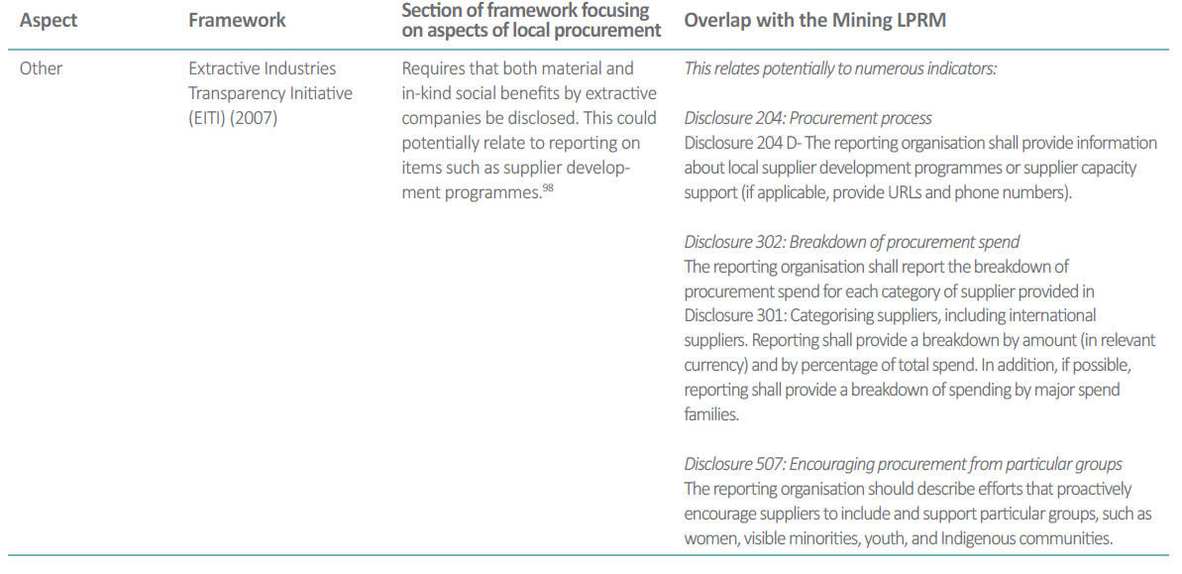
As outlined in the Appendix B of the LPRM which details overlap between the LPRM and existing sustainability frameworks, the following links are noted between EITI reporting and the Mining LPRM (Mining Local Procurement Reporting Mechanism, pg.76):

Given that “social benefits”, described in EITI reporting above, could be defined in a multitude of different ways, it is predictable that the level of local procurement aspects covered in EITI reporting will greatly vary both within and between member countries. However, based on the framing, it is likely that the focus will largely be placed on supports and services companies offer to build supplier capacity, for example through formal supplier development programmes. This means that site-level reporting of the procurement processes, local procurement spend, due diligence processes, incentives to procure locally, and the external commitments and obligations related to local procurement will not be captured in most cases.

Use of the LPRM will ensure that this valuable information is available, with a comprehensive set of local procurement disclosures which outline the specific information that is required to obtain a clear understanding of the state of local procurement for a given site. Given recent EITI efforts to advance project-level reporting, the LPRM is well-timed as it provides EITI members with the necessary disclosures on local procurement at a site-level that can be incorporated into this push for increased detail within company reporting.

Operationalizing the Mining LPRM in Member Countries

EITI members can utilize the Mining LPRM in different ways, ranging from dissemination and promotion, to eventual mandatory requirements for mine sites to report using all of the required disclosures.

In the short-term, activities could include: | In the long-term, activities could include:
- Country-level guidance and training to mining companies, mining associations, and other relevant stakeholders on local procurement reporting and detail on how it aligns with existing country reporting requirements.  - Support to civil society on how the LPRM could bolster current efforts and activities promoting improved mining governance.  - Training to governments on how the LPRM could support current data collection and economic planning (e.g. supplier support programs, educational spending, targeted infrastructure).  - Commitments from EITI national multi-stakeholder groups to support and promote the LPRM. | - Integrating all or select Mining LPRM disclosures into existing country reporting requirements and publishing this data within EITI reports.  - Integrating all or select Mining LPRM disclosures into existing country reporting requirements and publishing this data as part of a separate report focused on local procurement.

For more information about the Mining LPRM and how you can use it in your work, please contact Jeff Geipel (jeffgeipel@ewb.ca) or Emily Nickerson (emilynickerson@ewb.ca).

